Hey jackson, so here is a visual only representation of my game.

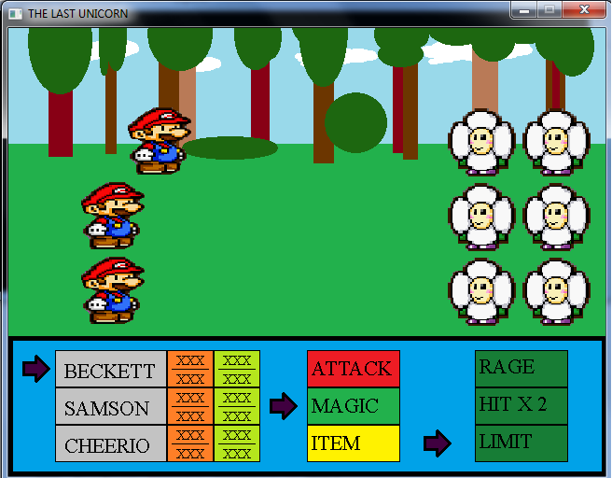

-take note that any keyboard or mouse clicks do nothing, the only functional button is the EXIT BUTTON.

- also do not draw the text in your artwork, I input the text over the images using code. So don’t worry about it

(NOW ON TO BUSINESS)

If you would kindly look inside the “rpg” folder you will find all of the things my program needs to run including the pictures. I haven’t worked with animation yet, so for now they are all “.png”

Each of these picture is the exact dimensions that I need ( except for the sky picture, since it scrolls it will be much wider)

But in case you are having trouble, here is a list of the pictures and list of dimensions (width, height):

The ones in red are the ones that need animations. The animation list follows the dimensions list.

* arrow(curser) - (30,30)
* health_counter – (50,120)
* magic_counter – (50,120)
* enemies(I need severl different varieties, but all the same size) – (75,75)
* character 1,2,3 – (75,75)
* attack_background – (100,40)
* magic_background – (100,40)
* magic_sub_background – (100,40)
* item_background – (100,40)
* item_sub_background – (100,40)
* character_background-(120,40)
* command_background-(640,150)
* background – (640,330)
* sky – (XXX,330) ( if you feel like animating it go ahead, it will look great either way)
* I could also use a title screen background, with title letters (640, 480)
* An icon for the executable(any size, the more high quality the better)
* A logo for all of us working on the game as a team(you, jared, tyler, and me)

animations:

* character1(knight)
  + regular stance
    - (just picture not animation)
    - (I’ll need some talking animation, so I can just use a clip from that)
  + Talking animation
    - (nothing fancy, just a mouth open and closed and maybe a hand movement)
  + attack stance
    - (just picture not animation)
  + sword attack animation
  + hit animation
    - this is where an enemy lands a hit
    - for this just have them keel over real quick then back to normal stance
  + magic attack animation
    - ( I’ll have several different magic, but the animation will be the same no matter what (maybe just hold sword up and make the sword shine)
  + item use animation
    - ( I’ll have several different items, but the animation will be the same no matter what)( mayber make him just hold out a cup with colored liquid in it)
  + Death animation
    - ( when dead they should just lie on the ground)
  + Revival animation
    - ( this is when “lazarus” is used, it brings a character back to life)
  + Limit animation
    - (each character has a special attack that will drain all of their magic)
    - In the case of the knight, his attack is him spinning and waving his sword(like a top))
    - He doesn’t have to go anywhere, I can do that later if I need to (I just need him spinning)
* Character2(dark mage)
  + regular stance
    - (just picture not animation)
    - (I’ll need some talking animation, so I can just use a clip from that)
  + Talking animation
    - (if you could have his head move when he talks that would be great and then I need some hand movement)
    - Also since he is the eventual bad guy he need one where he raises his hands out during his evil monologue
    - I need an animation of him taking his hood off and revealing his unicorn head
  + attack stance
    - (just picture not animation)
  + hit animation
    - this is where an enemy lands a hit
    - for this just have them keel over real quick then back to normal stance
  + knife attack animation
  + magic attack animation
    - ( I’ll have several different magic, but the animation will be the same no matter what (just have him hold his hand out and maybe have his clothes glow or something)
  + item use animation
    - ( I’ll have several different items, but the animation will be the same no matter what)( mayber make him just hold out a cup with colored liquid in it)
  + Death animation
    - ( when dead they should just lie on the ground)
  + Revival animation
    - ( this is when “lazarus” is used, it brings a character back to life)
  + Limit animation
    - (each character has a special attack that will drain all of their magic)
    - In the case of the dark mage, his attack is him waving both of his arms out very fast ( I’ll make some magic stuff happen)
* Character3(ninja)
  + regular stance
    - (just picture not animation)
    - (I’ll need some talking animation, so I can just use a clip from that)
  + Talking animation
    - (nothing fancy, just a mouth open and closed and maybe a hand movement)
  + attack stance
    - (just picture not animation)
  + Bow staff attack animation
  + hit animation
    - this is where an enemy lands a hit
    - for this just have them keel over real quick then back to normal stance
  + magic attack animation
    - ( I’ll have several different magic, but the animation will be the same no matter what (maybe just hold the staff up and make the it shine)
  + item use animation
    - ( I’ll have several different items, but the animation will be the same no matter what)( mayber make him just hold out a cup with colored liquid in it)
  + Death animation
    - ( when dead they should just lie on the ground)
  + Revival animation
    - ( this is when “lazarus” is used, it brings a character back to life)
  + Limit animation
    - (each character has a special attack that will drain all of their magic)
    - In the case of the ninja, his attack is him spinning his staff around himself
    - He doesn’t have to go anywhere, I can do that later if I need to.
* Enemies
  + (feel free to do anything for the enemies)
  + All that I need for sure is an attack animation, a non-attack stance, a hit animation, and a death
  + For the hit, you can just have “slash” look go through them, and then back to normal
  + For the death, they should fall down and just dissolve away to nothing
* Effects
  + For effects, you don’t have to put them right ontop of the characters, I can do that seamlessly,
  + But here are the effects:
    - Fire
    - Ice
    - Restore health/restore magic ( it can be the same ( maybe just different color)
    - Lazarus (sparkles ☺)
* UNICORN
  + The unicorn should take up the entire other half of the screen
  + For a hit just do a slash like before
  + For an attack have it lift its head and stab the air with it’s horn
  + For magic haveit’s eyes glow red or something
  + For it’s defeat have it fall face first into the ground( maybe with it’s horn keeping it stuck)
  + For the transformation to the giant unicorn, I’ll just do a flash back and forth between the original one and this new one. So don’t worry about animating that.